Test Case: tc001_SPX_Dev5_Crear_Solicitud_Articulo_Almacen
Step 1 - Enter username and password and click to button Enter : Credentials Entered
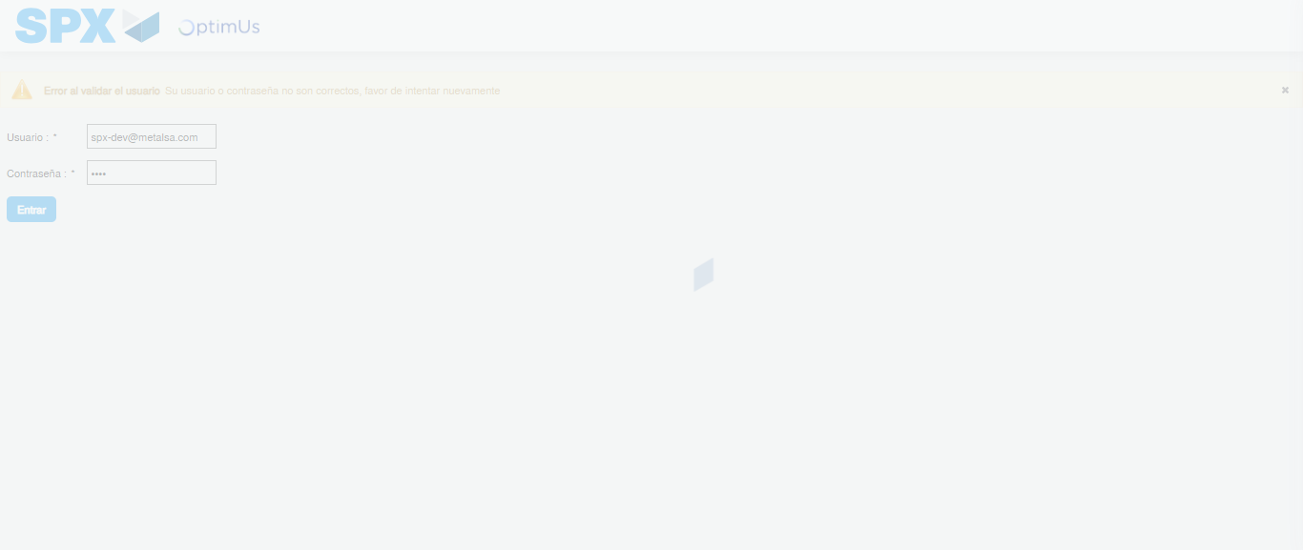Image file-name: QC_Testing-tc001_SPX_Dev5_Crear_Solicitud_Articulo_Almacen-1787840654385

Step 2 - Select to UEN and Access to Request for a New Inventory Item : UEN Correctly selected and Correct access
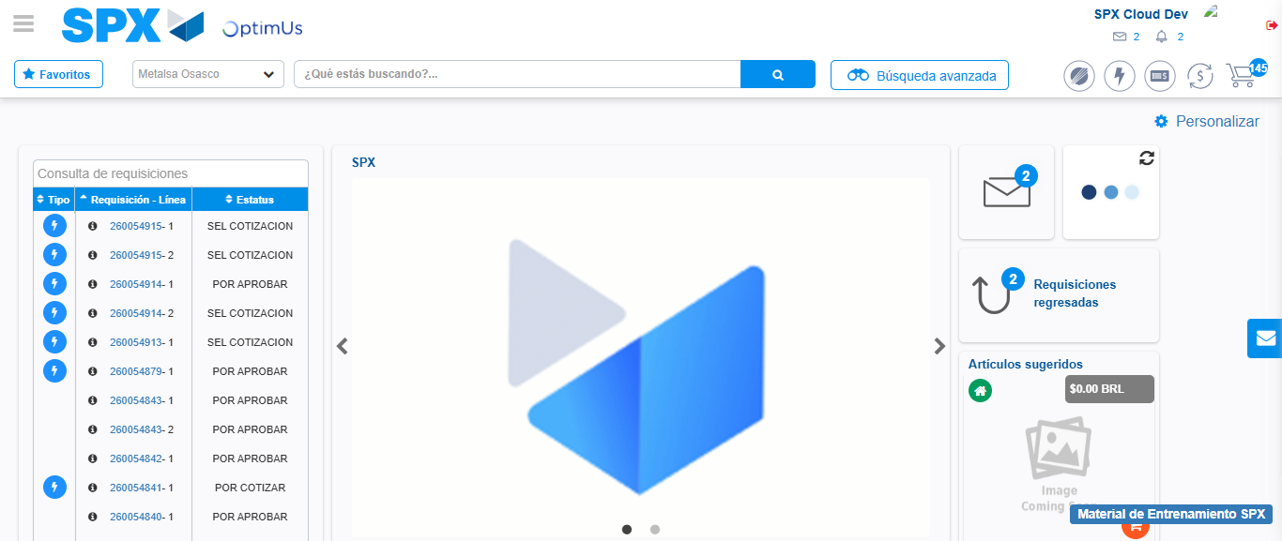Image file-name: QC_Testing-tc001_SPX_Dev5_Crear_Solicitud_Articulo_Almacen-1787840680350

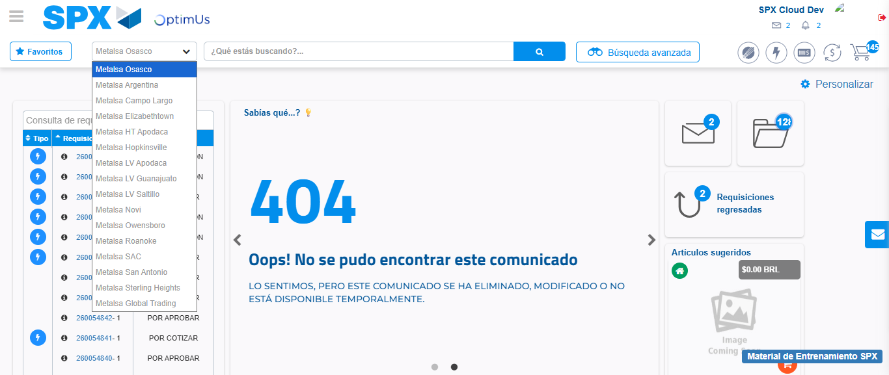Image file-name: QC_Testing-tc001_SPX_Dev5_Crear_Solicitud_Articulo_Almacen-1787840701439

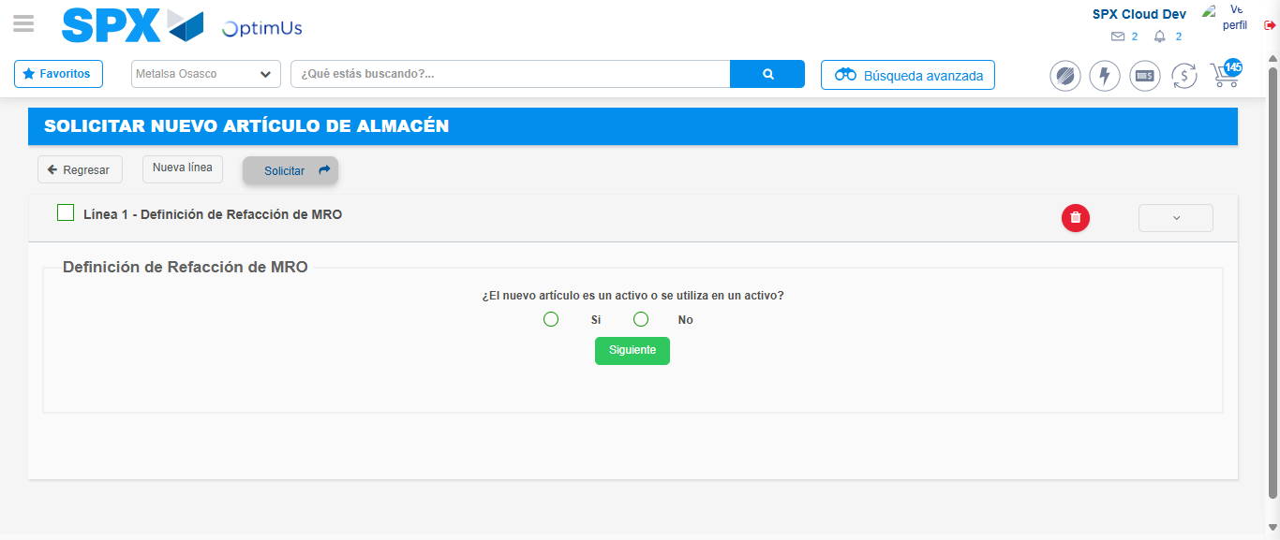Image file-name: QC_Testing-tc001_SPX_Dev5_Crear_Solicitud_Articulo_Almacen-1787840706319

Step 7 - Return to Main Page SPX : Return to Main Page SPX
Image file-name: QC_Testing-tc001_SPX_Dev5_Crear_Solicitud_Articulo_Almacen-1787840680350

Image file-name: QC_Testing-tc001_SPX_Dev5_Crear_Solicitud_Articulo_Almacen-1787840701439

Image file-name: QC_Testing-tc001_SPX_Dev5_Crear_Solicitud_Articulo_Almacen-1787840706319

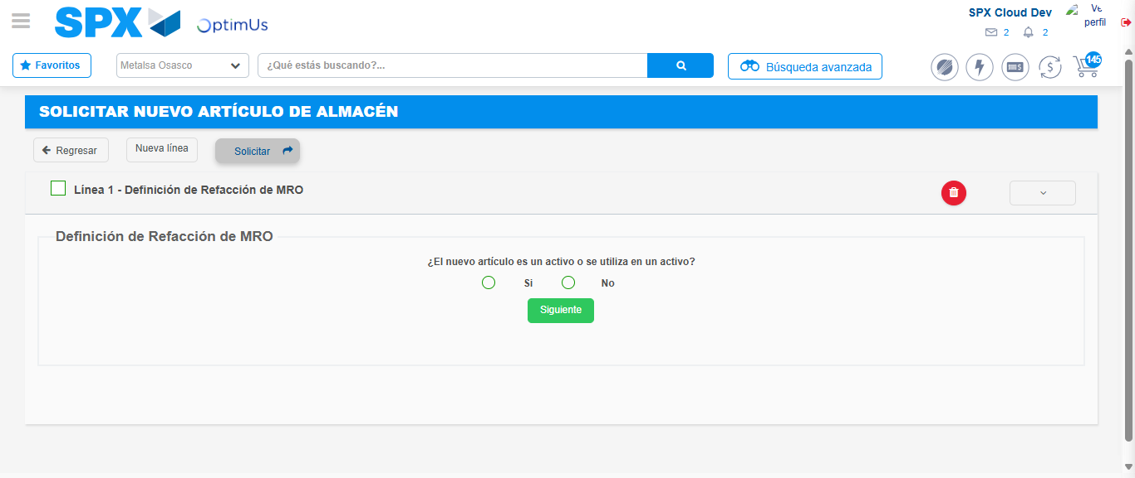Image file-name: QC_Testing-tc001_SPX_Dev5_Crear_Solicitud_Articulo_Almacen-1787840708975

Image file-name: QC_Testing-tc001_SPX_Dev5_Crear_Solicitud_Articulo_Almacen-1787840709175

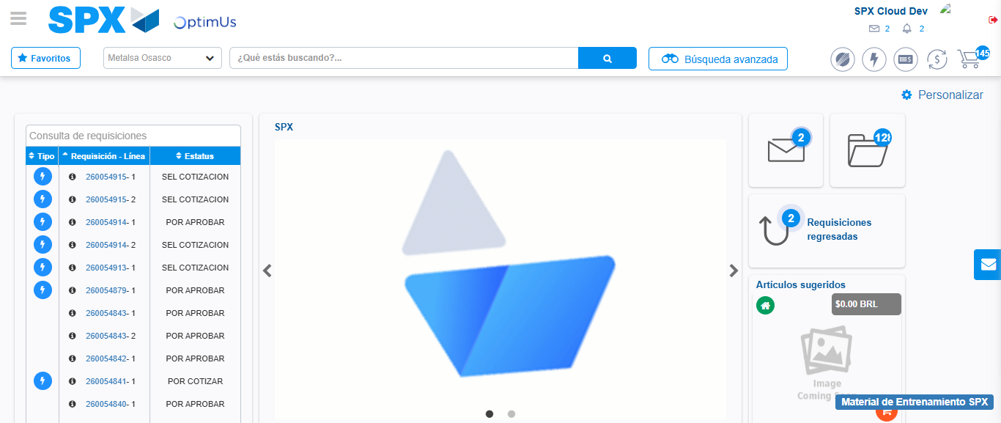Image file-name: QC_Testing-tc001_SPX_Dev5_Crear_Solicitud_Articulo_Almacen-1787840730490

Step 8 - Log Out : Log Out SPX
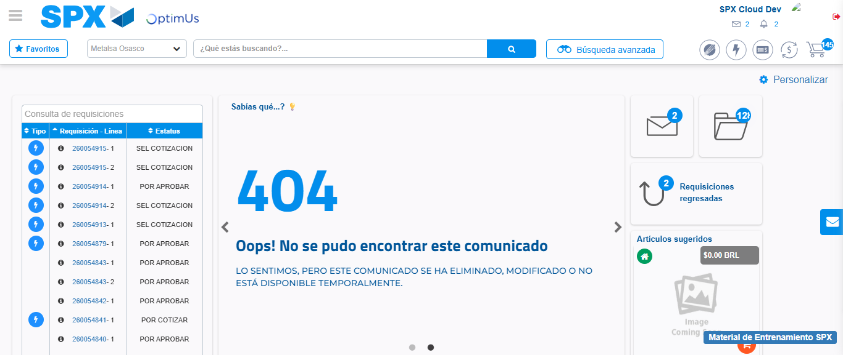Image file-name: QC_Testing-tc001_SPX_Dev5_Crear_Solicitud_Articulo_Almacen-1787840751167

